**Question of the Pivot Table**

|  |  |
| --- | --- |
| **Serial No** | **Question** |
| 1 | What is the total number of employees by department and identify which department contain most of the employee? |
| 2 | What are the average monthly sales by department present it graphically? |
| 3 | Which gender has the highest total monthly sales? |
| 4 | What is the distribution of employees across performance ratings show it graphically by bar chart? |
| 5 | What are the average years of experience for each department? |
| 6 | How many employees are in each gender group by turnover status and make a pie chart for turnover status "NO"? |
| 7 | What are the average annual training hours for employees who left (turnover status = Yes)? |
| 8 | What is the count of employees by education level in each department? |
| 9 | Which job role has the highest average years of experience? |
| 10 | How many employees are there in each age group by department? |
| 11 | Calculate the Job role vary by gender show the relation by graphically. |
| 12 | What are the average monthly sales for employees with a PhD? |
| 13 | How many employees have more than 5 years of experience in each department? |
| 14 | What is the turnover rate (percentage) for each department? |
| 15 | What are the average monthly sales for employees in each age group describe it by area chart? |

**Ans of the Pivot Table**

**Ans: 01**

What is the total number of employees by department and identify which department contain most of the employee?

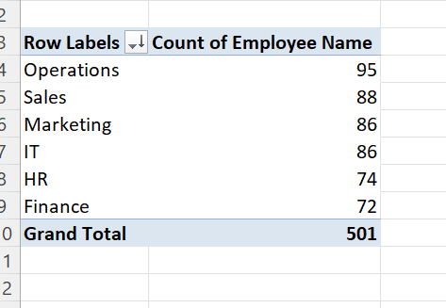

We can see that the relation between department and the employee’s name. Six department contain total 501 employee and Operations department contain of the most number of employee and thar was 95 and the second position department was Sales and it contain 88 employee’s.

**Ans: 02**

What are the average monthly sales by department present it graphically?

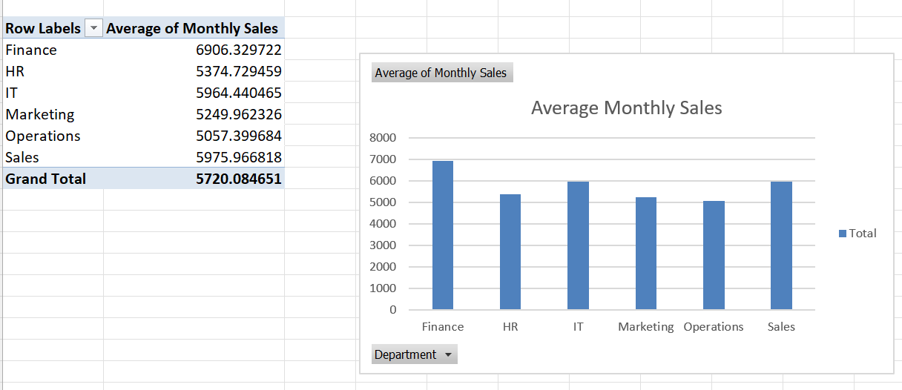

The show thar Finance department provide most average monthly sales and it was 6906.329622. And Operations department provide lowest average monthly sales. Here the total average monthly sales were 5720.084651 for the six department of the employee performance dataset.

**Ans: 03**

Which gender has the highest total monthly sales?

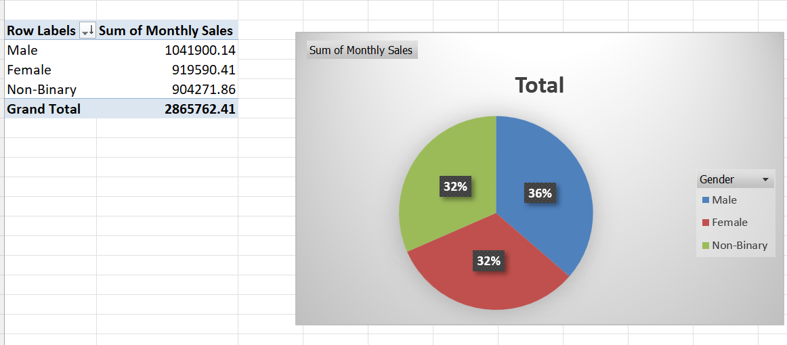

The pie chart shows that the total monthly sales by gender was 2865762.41 here we can see that the Male employees contain the most amount of total monthly sales. And secondly the Female employees contain the 2nd position of the total monthly sales. And last position contains non-binary employees and their total monthly sales was 904271.86.

**Ans: 04**

What is the distribution of employees across performance ratings show it graphically by bar chart?

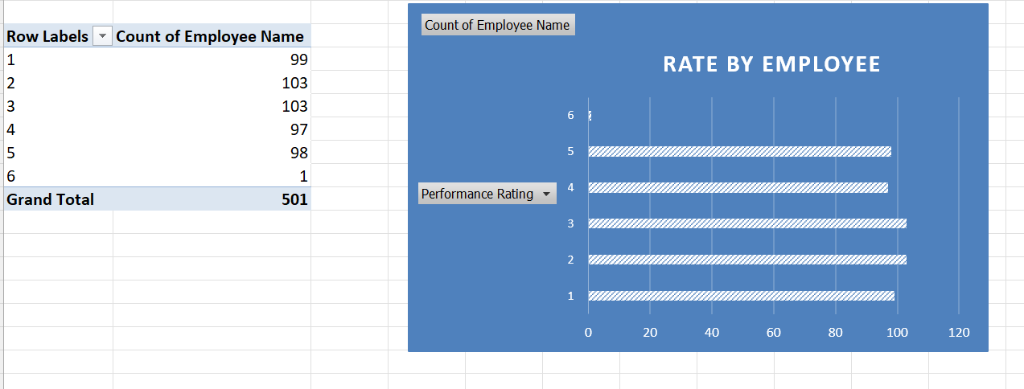

The bar chart shows that the count number depend on the performance rating. When the performance rate was 2 and 3 the employee was highest and it 103 persons. The highest rate was 6 but the employee only 1 person.

**Ans: 05**

What are the average years of experience for each department?

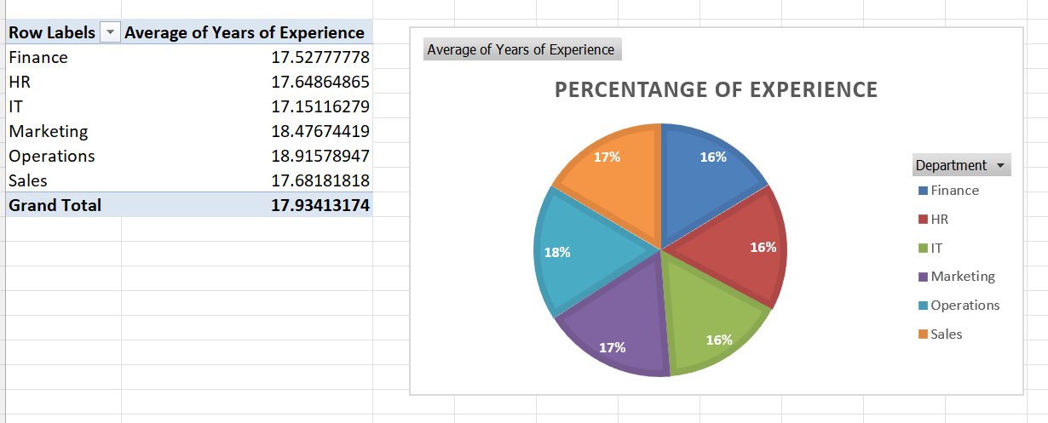

Pie chart shows that the average year of experience for the six department. We can see that the Finance departments average year of experience was 17.52777778 it means it was actually 16% and the HR departments average year of experience was also 16% and the highest average experience was 18% and it was the Operations department.

**Ans: 06**

How many employees are in each gender group by turnover status and make a pie chart for turnover status "NO"?

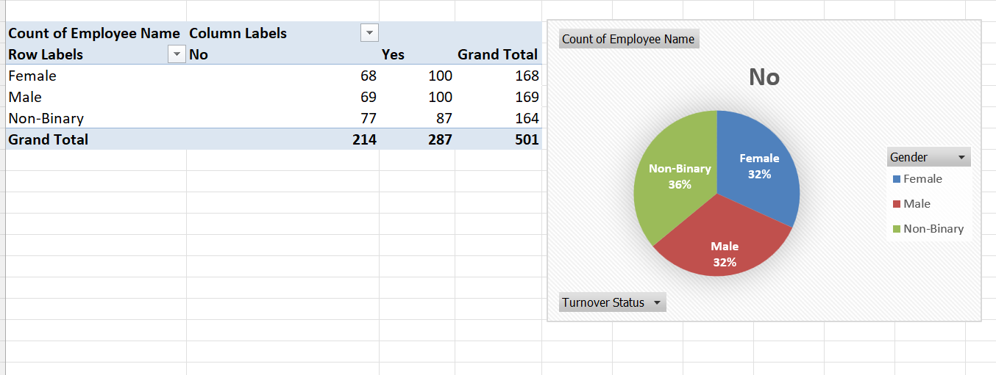

Here the Pie chart show us that only for the turnover status “NO”. Then the Female employee was 32% it means only 68. Male employee was also 32% but the employee was 69. At last, the pie chart describes that the non-binary employee was 36% and the employee was 77 it was the highest rate for turnover status “NO”.

**Ans: 07**

What are the average annual training hours for employees who left (turnover status = Yes)?

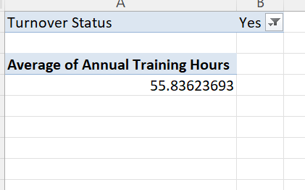

Here we can see that the average annual training hours for employees and their turnover status was yes and the value was 55.83623693

**Ans: 08**

What is the count of employees by education level in each department?

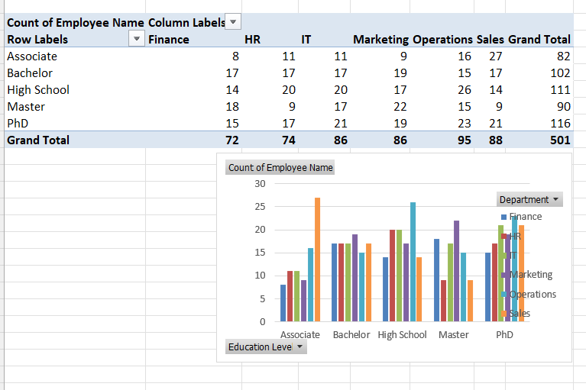

The bar chart show that the relation between education level and the department for count the employee. First for associate level of education the sales department was high and the next for bachelor level of education the marketing department contain most of the employee. Third for high school level of education the finance department contain the most number of the employee.

**Ans: 09**

Which job role has the highest average years of experience?

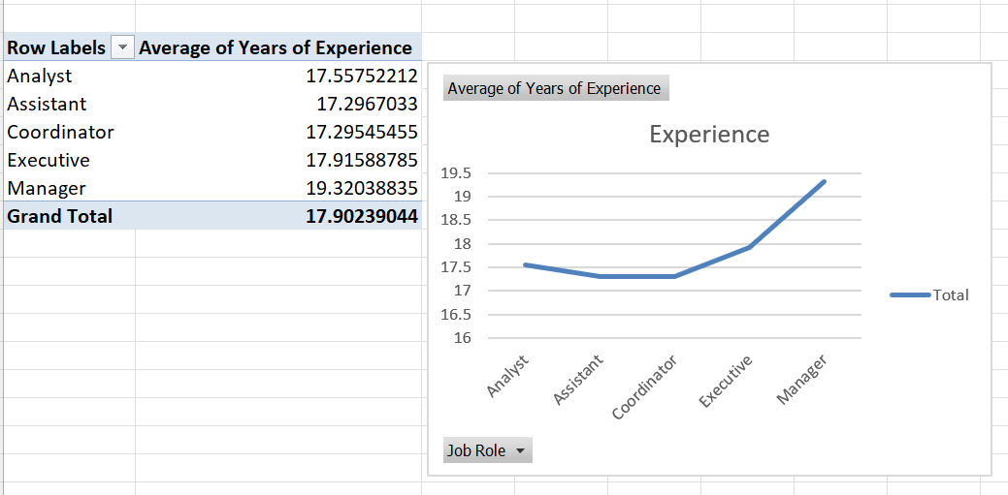

From the dataset, the line chart show that the five kinds of job role for the employee and their average years of experience. Here the coordinator job role has lowest average year of experience and the manager job role has highest average year of experience and it was 19.32038835. The line chart also show that the line is ascending.

**Ans: 10**

How many employees are there in each age group by department?

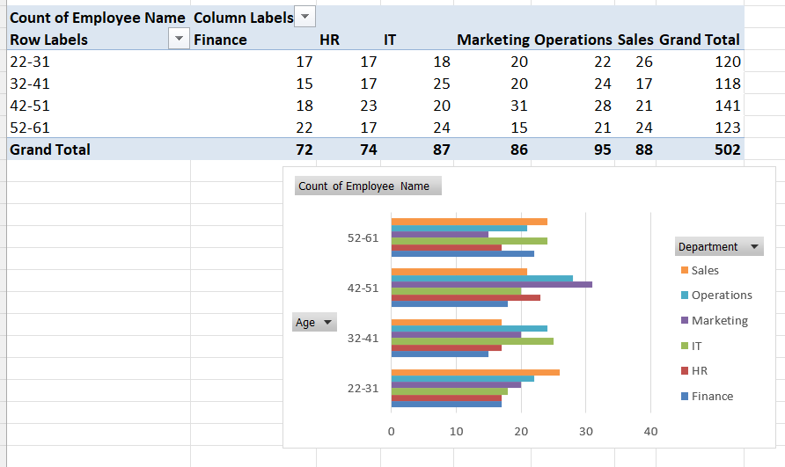

The bar chart show that the there are four group of age and the minimum age is 22 and the maximum age is 61 and the difference between the max and min for one age group is 10. Here 1st group contain 120 employee and the 2nd group contain 118 employee and the 3rd group contain 141 employee and the last group contain 123 employees.

Ans: 11

Calculate the Job role vary by gender show the relation by graphically.

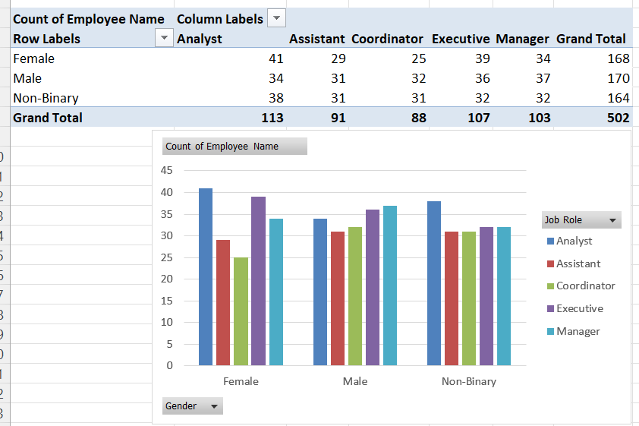

Here the graph shows us that for female the highest employee for the analyst post and the lowest employee for the coordinator post and the number was 25. Secondly for male employee highest for the manager post and the number was 37, the lowest employee for the assistant post and the number was 31.

**Ans: 12**

What are the average monthly sales for employees with a PhD?

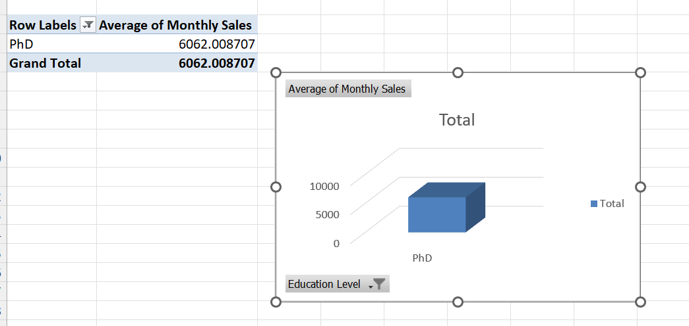

Here the chart show that the average monthly sales for employees with a PhD was 6062.008707.

**Ans: 13**

How many employees have more than 5 years of experience in each department?

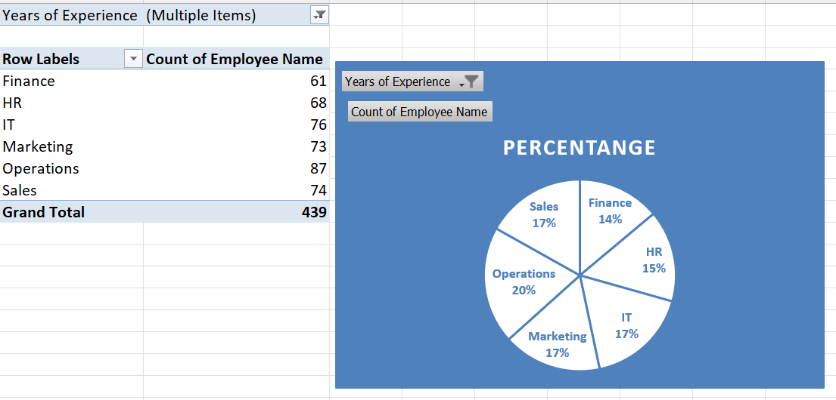

Here the pie chart show that the total 439 employees have more than 5 years’ experience by each department. Here the operations departments employees have more than 5 year’s experiences and the rate 20% the rate was highest. And the Finance department have the lowest rate and it 14%.

**Ans: 14**

What is the turnover rate (percentage) for each department?

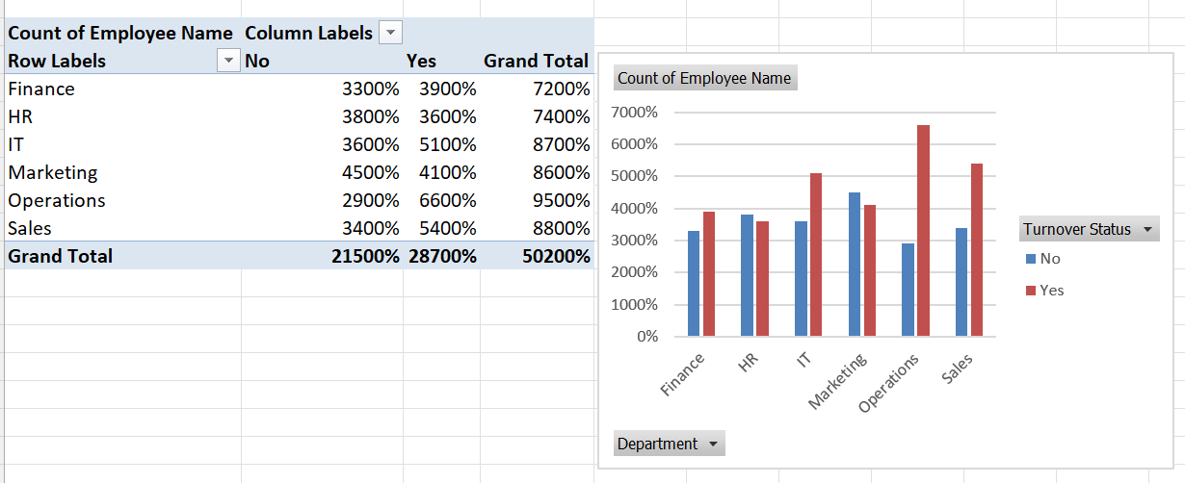

Here the chart show that the six department have different turnover feedback. Finance department show when turnover status No the rate was 33% and for status Yes, the rate was 39%. For the Operations department show when turnover status No the rate was 29% and for status Yes the rate was 66%

Ans: 15

What are the average monthly sales for employees in each age group describe it by area chart?

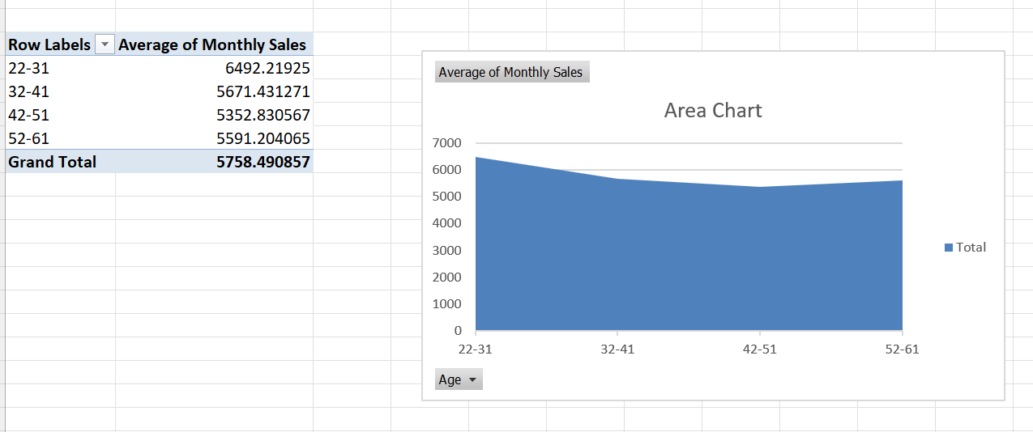

Here the area chart shows that average monthly sales by different age groups. Firstly, here the 1st groups average monthly sales was highest and it was 6492.21925. And the next age group we can see that the average monthly sales is decreasing. The last age group (52-61) contain 5591.204065 average monthly sales.